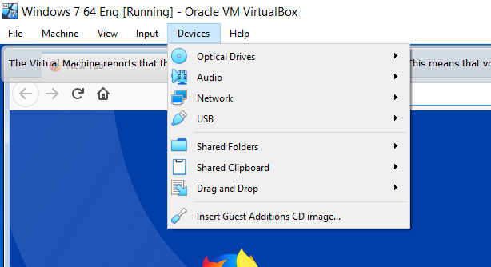

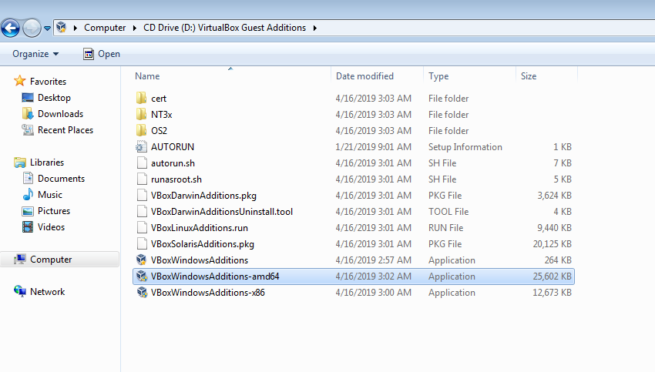

Is a Connection between real machine and virtual machine to be able to do various things -copy/past stuff- enlarge responsively